X International Tournament “SKOPJE OPEN 2019”

& Second Round of Adriatic League

Dear sports friends,

We would like to inform you that the Macedonian Ju-Jitsu Federation is organizing an international tournament in Ju-Jitsu, in fighting, duo system, duo-show and ne waza on the 09th of November 2019 in Skopje. Through this call we would like to invite your presence of our tournament.

TOURNAMENT IN JU-JITSU FIGHTING, DUO-SYSTEM, DUO-SHOW AND NE-WAZA FOR CHILDREN, PIONEERS, CADETS, JUNIORS AND SENIORS IN MEN`S AND WOMEN`S COMPETITION.

Date | 09th November, 2019 (Saturday)
Place | Sports hall “Independent Macedonia”– ES “Nevena Georgieva Dunja” – Skopje, ST. Mihail Chakov No.9
Organizer | Macedonian Ju-Jitsu Federation
Information | +389 75998834 ; +389 70 266 911
Application | Until 12.00 p.m. , 31stOctober, 2018  e-mail: jujitsu.mk@gmail.com , dacaikido@gmail.com
Fee | - All Cathegories:  fight & Ne Waza 10 € (children, pioneers);  fight & Ne Waza 15 € (older pioneers ,cadets, јuniors и seniors);  - 2 categories 15 € (children, pioneers);  - 2 categories 25 € (older pioneers, cadets, јuniors и seniors);  - Duo system/show 20 € (children, pioneers);  - Duo system/show 30 € (older pioneers, cadets, јuniors и seniors)  The payment can be made to the bank account of the Federation :  - 210-065480400161, depositor NLB Tutunska Banka ( proof- copy of the depositor slip)  - On the day of the tournament, at the cashier of the Federation in cash.

Accommodation | The tournament organizer for all participants would provide  accommodation in  “Mladinski hotel’’ Skopje,  https://www.facebook.com/MladinskiHotel/  Price:  - 19 € per night with breakfast  - 24 € per night with breakfast and dinner  “Hotel Continental” Skopje,  http://www.hotelcontinental.com.mk/  Luxury rooms Price:  - 37 € per night with breakfast / single bed  - 27 € per night with breakfast / double bed  Economy rooms Price:  - 27 € per night with breakfast / single bed  - 34 € per night with breakfast and dinner / single bed  - 21 € per night with breakfast / double bed  - 28 € per night with breakfast and dinner / double bed  "Mladisnki Hotel is located in the center of the city. St. Prolet No.25.  "Hotel Continental" is located on address Blvd. Alexander the Great  All hotels have free parking space  Note: due to the accommodation organization, we would like to ask  you, beside the application of the tournament, the participants to submit information to the organizer about the arrival time and how many people will use the offered accommodation.  Booking is the principle - first registered, first served
Awards | Medals and diplomas for individual ranking  A cup for the best male contestant  A cup for the best female contestant  A cup for the best placed team (with most winning medals)  A cup for the most perspective /up-and coming child- fighter
Rules | JJIF  Note: in case there isn`t sufficient number of contestants in a certain  category, the organizer keep its right to put them in one category.  Note: Control weights on Friday (08.11.2019)  Mladisnki Hotel – 21:00h  Hotel Continental – 20:00h
Schedule | 07:30 – 8:30 | Control weights
Schedule | 8:30 – 9:00 | Payment of fee
Schedule | 9:00 – 9:30 | Meeting with the referees, team leaders and the  host
Schedule | 9:30 -10:00 | Teams standing in line and official opening of the  tournament
Schedule | 10:00 | Official start of the tournament
Schedule | 15:30 | Award medals and diplomas
Schedule | 16:00 | 2 Round of Adriatic League

REFEREES:

The clubs- participants of the tournament could delegate referees for the fights which have a valid referee license. For this tournament the choice of the referees will be made by the referee with the highest license. The referees’ suggestion should be submitted with the application for contestants and officials. At the meeting for referees and team leaders, all clubs will be informed about the selected referees.

COACHES - TEAM LEADERS:

Club representatives that will take part in the tournament (coaches and team leaders) at the time of teams’ application and fee payment from the Delegate of the tournament will receive two accreditations for the team leaders. The entrance in the area provided for fights during the tournament will be allowed only for the called competitors that will fight (in a kimono) and the team leaders who have clearly appointed their accreditation.

The REST:

- Only the contestants who have a proof of a valid membership card can take part at the tournament, but for the participants who are not members of the Federation, a proof of ID will be needed – personal or sport document.
- The team leaders should possess a proof for paid insurance and a medical certificate for
the registered contestants not older than 12 months.
- The organizer of this tournament is not responsible for personal injures loss or damage of the contestants` personal belongings and to the club, which takes part into the tournament. Inconveniences that will eventually occur during the tournament`s participation or travelling.
- We ask the team leaders to adhere to the above mentioned program of the tournament and the rest of the activities, to have on time performance form their contestant in the fight, due to the limited time of the sport`s hall availability.
- The clubs responsibility is to provide prescribed protective equipment, blue and red belts, protectors/shields and gloves.
- The organizer will provide a lunch for the referee.
- One contestant can take part in two categories, in one`s own and in the next weight or age category. The same rule is applicable for the competitions in duo systems.
- Judges and technical staff from abroad will be paid per diem and will have free night

Duo system categories:

Age | Age
Children | Not older than 8
Pioneers | 9/10/11
Older pioneers | 12/13/14
Cadets | 15/16/17
Juniors | 18/19/20
Seniors | Older than 21

Children | Pioneers |  |  | Senior  Pioneers | Cadets | Juniors | Seniors
2 series |  | 2 series |  | 3 series | 4 series | 4 series | 4 series
Duo and duo mix |  |  | - Children perform 2 techniques of their free choice from  series A and B (according to JJIF)  - Pioneers perform 2 techniques of their free choice from  series A, B and C (according to JJIF)  - Senior Pioneers perform 3 techniques of their free choice  from series A, B and C (according to JJIF)  4. Cadets, Juniors and Seniors perform 4 techniques according to JJIF
Duo Show |  |  | 1. Children, Pioneers and Older Pioneers (Free choice maximum 1.5 min)  2. Cadets, Juniors and Seniors (JJIF 10 attacks, minimum 2 of each series, maximum 3 min)

Fights categories:

Rules |  |  | JJIF
Age  categories | Age |  |  |  |  |  |  |  | Age
Weights categories | Children |  |  |  |  |  |  |  | (U10) 2010-2012
Weights categories | Children |  |  |  |  |  |  |  | (U12) 2008-2009
Weights categories | Children |  |  |  |  |  |  |  | (U14) 2006-2007
Weights categories | Older pioneers |  |  |  |  |  |  |  | (U16) 2004-2005
Weights categories | Cadets |  |  |  |  |  |  |  | (U18) 2002-2003
Weights categories | Juniors |  |  |  |  |  |  |  | (U21) 1999-2001
Weights categories | Seniors |  |  |  |  |  |  |  | 21+ (under 1998)
Weights categories | Men | Seniors  21+ |  |  | Juniors  (U21) |  | Cadets  (U18) | Older  Pioneers  (U16) |  | Children  (U14) | Children  (U12) | Children  (U10)
Weights categories | Fights | 1 ×3 min |  |  | 1 ×3 min |  | 1 ×3 min | 1 ×2 min |  | 1 ×2 min | 1 ×2 min | 1 ×2 min
Weights categories | Fights | -56 kg |  |  | -56 kg |  | -46 kg | -38 kg |  | -30 kg | -24 kg | -21 kg
Weights categories | Fights | -62 kg |  |  | -62 kg |  | -50 kg | -42 kg |  | -34 kg | -27 kg | -24 kg
Weights categories | Fights | -69 kg |  |  | -69 kg |  | -55 kg | -46 kg |  | -38 kg | -30 kg | -27 kg
Weights categories | Fights | -77 kg |  |  | -77 kg |  | -60 kg | -50 kg |  | -42 kg | -34 kg | -30 kg
Weights categories | Fights | -85 kg |  |  | -85 kg |  | -66 kg | -55 kg |  | -46 kg | -38 kg | -34 kg
Weights categories | Fights | -94 kg |  |  | -94 kg |  | -73 kg | -60 kg |  | -50 kg | -42 kg | -38 kg
Weights categories | Fights | +94 kg |  |  | +94 kg |  | -81 kg | -66 kg |  | -55 kg | -46 kg | -42 kg
Weights categories | Fights |  |  |  |  |  | +81 kg | -73 kg |  | -60 kg | -50 kg | +42 kg
Weights categories | Fights |  |  |  |  |  |  | +73 kg |  | -66 kg | +50 kg
Weights categories | Fights |  |  |  |  |  |  |  |  | +66 kg
Weights categories | Women |  |  | Seniors  21+ |  | Juniors  (U21) | Cadets  (U18) | Older  Pioneers  (U16) |  | Children  (U14) | Children  (U12) | Children  (U10)
Weights categories |  |  |  | 1 ×3 min |  | 1 ×3 min | 1 ×3 min | 1 ×2 min |  | 1 ×2 min |  | 1 ×2 min
Weights categories |  |  |  | -45 kg |  | -45 kg | -40 kg | -32 kg |  | -25 kg | -22 kg | -20 kg
Weights categories |  |  |  | -48 kg |  | -48 kg | -44 kg | -36 kg |  | -28 kg | -25 kg | -22 kg
Weights categories |  |  |  | -52 kg |  | -52 kg | -48 kg | -40 kg |  | -32 kg | -28 kg | -25 kg
Weights categories |  |  |  | -57 kg |  | -57 kg | -52 kg | -44 kg |  | -36 kg | -32 kg | -28 kg
Weights categories |  |  |  | -63 kg |  | -63 kg | -57 kg | -48 kg |  | -40 kg | -36 kg | -32 kg
Weights categories |  |  |  | -70 kg |  | -70 kg | -63 kg | -52 kg |  | -44 kg | -40 kg | -36 kg
Weights categories |  |  |  | +70kg |  | +70kg | -70 kg | -57 kg |  | -48 kg | -44 kg | -40 kg
Weights categories |  |  |  |  |  |  | +70 kg | -63 kg |  | -52 kg | -48 kg | +40 kg
Weights categories |  |  |  |  |  |  |  | +63kg |  | -57 kg | +48kg
Weights categories |  |  |  |  |  |  |  |  |  | +57kg
The other |  |  | - Two third place (for fights and duo systems)  - One contestant can take part in its own or in the next (age or weight) category  3. Zero tolerance for weight.

 | Children
Ashi Waza:
O Soto Guruma
Uchi Mata (If Tori falls directly on the floor with Uke)
Koshi Waza:
Sode Tsuri Komi Goshi
Harai/Hane Goshi (If Tori falls directly on the floor with Uke)
Kata - Te - Waza:
Seoi Nage (Ifthe knees are on the floor)
Таi Отоshi (If Tori falls directly on the floor with Uke) Kata Guruma (from standing position)
Sutemi-Waza:
Tani Otoshi Soto Maki Komi
Forbidden
throwing  techniques | Pioneers
throwing  techniques | Ashi Waza:  O Soto Guruma  Uchi Mata (If Tori falls directly on the floor with Uke)
throwing  techniques | Koshi Waza:  Harai/Hane Goshi (If Tori falls directly on the floor with Uke)
throwing  techniques | Kata - Te - Waza:  Seoi Nage (Ifthe knees are on the floor)  Таi Отоshi (If Tori falls directly on the floor with Uke) Kata Guruma (from standing position)
throwing  techniques | Sutemi-Waza:  Tani Otoshi
throwing  techniques | Strokes with head and sacrifice techniques are not permitted  Lever and drowning are forbidden
Forbidden throwing techniques | Older pioneers
Forbidden throwing techniques | Ashi Waza:  Uchi Mata (If Tori falls directly on the floor with Uke)
Forbidden throwing techniques | Koshi Waza:  Hаnе Gоshi (If Tori falls directly on the floor with Uke)
Forbidden throwing techniques | Kata - Te - Waza:  Seoi Nage (Ifthe knees are on the floor) Kata Guruma (from standing position)
Forbidden throwing techniques | Lever and drowning are forbidden

APPILCATION FORM
International tournament “SKOPJE OPEN 2019”

Club Address Tel e-mail

Number | Name and surname | Birth  Year | Sex | Weight  category | DUO System/Show
1
2
3
4
5
6
7
8
9
10
11
12
13
14
15
16
17
18
19
20

Referees : _
_
_ _ Coach/ Leader : _

C A T E G O R I E S
NE WAZA
International Tournament “SKOPJE OPEN 2019”
Categories  Man | Kids | Pioneers | Older Pioneers | Cadets | Juniors | Seniors | Seniors
Categories  Man | to 8 | (11,10,9) | (12,13,14) | (15, 16, 17) | (18, 19, 20) | 21+ | (+ 36 год.)
Time | 3 min | 4 min | 4 min | 4 min | 6 min | 6 min | 5 min
Weight categories | -21 kg | -24 kg | -34 kg | - 46kg | - 62kg | - 62kg | - 62kg
Weight categories | -24 kg | -27 kg | -37 kg | - 50kg | - 69kg | - 69kg | - 69kg
Weight categories | -27 kg | -30 kg | -41 kg | - 55kg | - 77kg | - 77kg | - 77kg
Weight categories | -30 kg | -34 kg | -45 kg | - 60kg | - 85kg | - 85kg | - 85kg
Weight categories | -34 kg | -38 kg | -50 kg | - 66kg | - 94kg | - 94kg | - 94kg
Weight categories | -38 kg | -42 kg | -55 kg | - 73kg | + 94kg | + 94kg | + 94kg
Weight categories | -42 kg | -46 kg | -60 kg | - 81kg
Weight categories | +42 kg | -50 kg | -66 kg | + 81kg
Weight categories |  | +50 kg | +66 kg
Leg controls | Not allowed | Not allowed | Not allowed | Not allowed | Not allowed |  | Not avowed
Start position | On knees | Standing | Standing | Standing | Standing | Standing | On knees
Categories Females | Kids | Pioneers | Older Pioneers | Cadets | Juniors | Seniors | Seniors
Categories Females | До 8 | (11,10,9) | (12,13,14) | (16, 17, 18) | (19, 20, 21) | 21+ | (+ 36 год)
Time | 3 min | 4 min | 4 min | 4 min | 6 min | 6 min | 5 min
Weight categories | -20 kg | -22 kg | -32 kg | - 40kg | - 55kg | - 55kg | - 55kg
Weight categories | -22 kg | -25 kg | -36 kg | - 44kg | - 62kg | - 62kg | - 62kg
Weight categories | -25 kg | -28 kg | -40 kg | - 48kg | - 70kg | - 70kg | - 70kg
Weight categories | -28 kg | -32 kg | -44 kg | - 52kg | + 70kg | + 70kg | + 70kg
Weight categories | -32 kg | -36 kg | -48 kg | - 57kg
Weight categories | -36 kg | -40 kg | -52 kg | - 63kg
Weight categories | -40 kg | -44 kg | -57 kg | - 70kg
Weight categories |  | -48 kg | -63 kg | + 70kg
Weight categories |  | +48 kg | +63kg
Leg controls | Not allowed | Not allowed | Not allowed | Not allowed | Not allowed |  | Not allowed
Start position | On knees | Standing | Standing | Standing | Standing | Standing | On knees

APPILCATION FORM
NE WAZA

International tournament “SKOPJE OPEN 2019”

Club Address Tel e-mail

Number | Name and surname | Birth  Year | Sex | Weight category
1
2
3
4
5
6
7
8
9
10
11
12
13
14
15

Referees: _ _

Coach/ Leader :

Location of Sports hall: https://www.google.com/maps/place/%D0%9E%D0%A3+%D0%9D%D0%B5%D0%B2%D0%B5%D0%BD%D0%B0+%D0%83%D0%B5%D0%BE%D1%80%D0%B3%D0%B8%D0%B5%D0%B2%D0%B0+%D0%94%D1%83%D1%9A%D0%B0/@41.980697,21.445878,16.54z/data=!4m5!3m4!1s0x0:0xf0a2991fd41bc32b!8m2!3d41.9803545!4d21.4451583

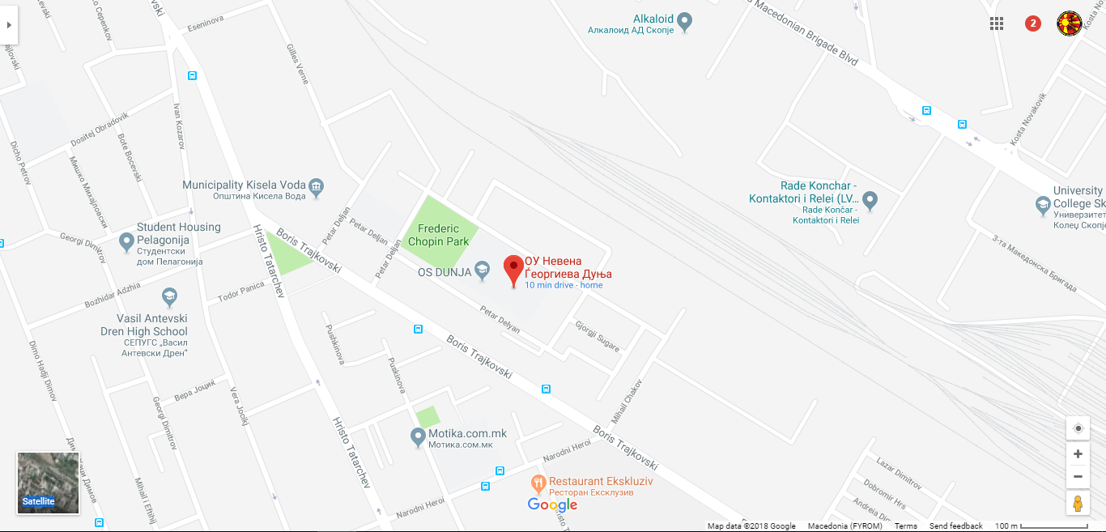

Skopje, capitol city of R. Macedonia

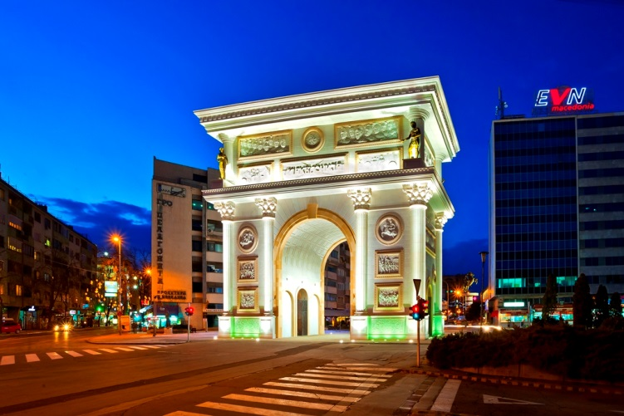 | 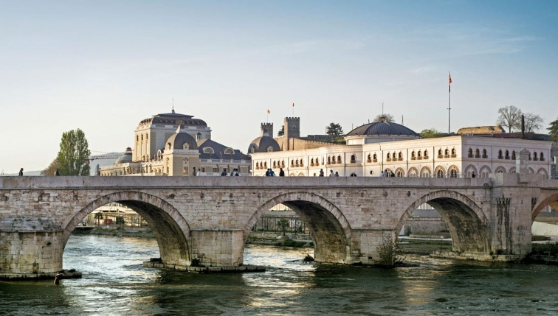
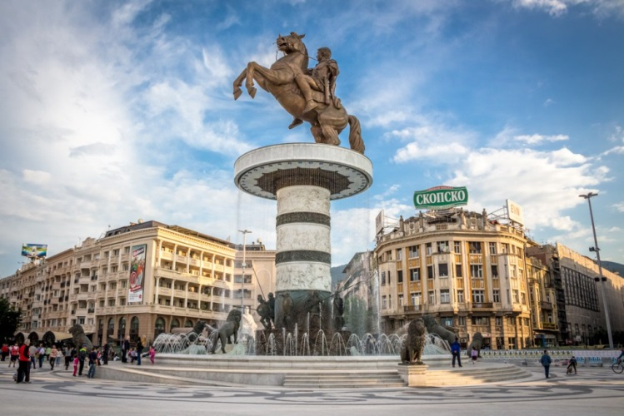 | 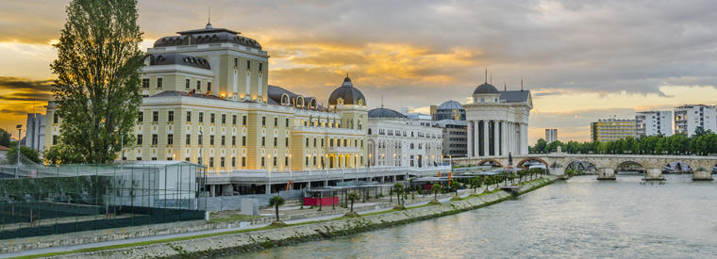
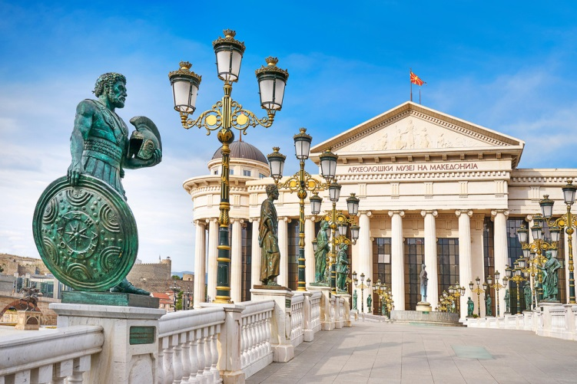 | 